**CHAPTER 01**

**INTRODUCTION**

Online kids shopping management is an innovative way to manage the shopping needs of children. It allows parents to easily keep track of their children’s purchases, without the hassle of physical shopping. It also makes it easier to compare prices from different online stores, to find the best deals for their kids. With online kids shopping management, parents can easily set up budgets for their children, set up payment methods, and track their spending. In addition, they can also set up reminders for themselves when items are running low or when their children’s allowance needs to be replenished. This type of online shopping management makes it easier for parents to keep their children’s shopping needs in check, while still giving them the freedom to shop whenever they want.

For sellers, their product has access to the World-Wide market, which also increases the number of customers and enhances customer relationships. Also, web stores are a means for small-scale companies to launch their products at the global level. The main objective of this project is to develop a web site that can provide an online shopping feature to users.

This is achieved by searching suitable information from the accumulated data pertaining to the user’s history of visiting particular places. People nowadays pay more attention to their appearances especially when it concerns clothes, wearing different clothes depending on with whom they will be meeting or avoiding not to wear the same clothes the next day. Currently, a method which conveniently acquires the data on user’s clothing habits and provides useful information to him/her based on the accumulated data is not available. Thus, to discuss a service where the existing clothing industry, IT-converged services, and CT are integrated to allow customers to participate in the design process and share their designs with others, an application which recommends a suitable design to the designer by accumulating the history of clothing choices of these customers to grasp a particular customer’s clothing habits or inclination has been proposed. All of these tasks can be performed and managed with a smart device.

In this project we will be focused at developing an website for kids clothing and sell the products. We will also be maintaining the database of the users, stock sold and available stock.

After the implementation of the system users/customers can place an order for their clothes.

The aim is to automate its existing manual system by the help of computerized equipments and full-fledged computer software, fulfilling their requirements, so that their valuable data/information can be stored for a longer period with easy accessing and manipulation of the same. Basically the project describes how to manage for good performance and better services for the clients.

* 1. **PROCESSES**

The process for an online kid’s shopping management system according to the customer's perspective could include the following steps:

1. **Search and Browse:** Customers can search for products using keywords or browse through various categories and subcategories.
2. **Product Information:** Customers can view detailed information about the products including images, description, pricing, and reviews.
3. **Add to Cart:** Customers can add items to their cart as they shop.
4. **Review Cart:** Customers can review the items in their cart, make changes to the quantity or remove items as needed.
5. **Checkout:** Customers can enter their shipping information, choose a shipping method, and proceed to payment.
6. **Payment Processing:** Customers can choose from various payment options such as credit card, debit card, net banking, or e-wallet.
7. **Order Confirmation:** Customers receive an order confirmation email with details of their purchase, including the items purchased, shipping address, and estimated delivery date.
8. **Track Order:** Customers can track the status of their order through the website or by email.
9. **Customer Service:** Customers can contact customer service if they have any questions or issues with their order.
10. **Return and Refund:** Customers can initiate a return or refund through the customer service portal if they are not satisfied with their purchase.
11. **Account Management:** Customers can create an account on the website, view their order history, and update their personal information.
12. **Product Reviews:** Customers can leave feedback and ratings on the products they purchase to help other customers make informed decisions.
13. **Wishlist:** Customers can save their favourite items to their wish list for future purchase.
14. **Notifications:** Customers will be notified by email or push notifications about any updates on their order, special promotions or new products.
15. **Personalized Recommendation:** The system will provide personalized product recommendations to customers based on their browsing and purchase history.

The process for an online kid’s shopping management system according to the admin's perspective could include the following steps:

1. **Product Management:** Admins can add, edit, and delete products from the system, including item name, description, price, and images.
2. **Inventory Management:** Admins can manage the inventory levels, track stock availability and order new stock as needed.
3. **Order Management:** Admins can view, update and manage customer orders, including order status, shipping details, and payment information.
4. **Customer Management:** Admins can view customer information, including account details and order history, and manage customer requests and complaints.
5. **Shipping Management:** Admins can manage shipping options and rates, integrate with shipping providers and track packages.
6. **Payment Management:** Admins can manage payment options, integrate with payment gateways, and track transaction history.
7. **Marketing and Promotion:** Admins can create and manage email campaigns, referral programs, and special promotions to increase sales and customer engagement.
8. **Reporting and Analytics:** Admins can view key performance indicators such as sales, customer behaviour, and website traffic, and use this data to make informed decisions about the business.
9. **Security:** Admins can manage security settings and monitor for potential security threats to protect customer information and prevent unauthorized access.
10. **Website Management:** Admins can manage the website's appearance, layout, and functionality, including updating the design, adding new features, and managing user access.
11. **User Management:** Admins can manage the user accounts, roles, and permissions, assign tasks and monitor the activities of other users.
12. **Financial Management:** Admins can manage the financials of the business, including invoicing, accounting, and tax compliance.
13. **Compliance:** Admins can ensure that the business is in compliance with regulations and laws related to e-commerce and data privacy.

Top of Form

Top of Form

Top of Form

* 1. **OBJECTIVES**

The process of buying products and services through the channel of the internet is called online shopping. It has great advantages over real markets. Many online stores are giving their best services to the people. The system of online shopping has increased it so vast. By sitting at any corner of the world you can avail the services. Due to the online shopping system, you can shop for any product from any place and get the delivery at your home. This online system has made it possible to approach any world’s market easily.

1. **Manage the shopping details**: The whole system of online shopping manage the detail of each shopping done by the customers. They extract the product details of what consumers shopped.
2. **Manage the payment details:** In online shopping, customers get many options for mode of payments. Websites give them the option of online payment through debit or credit cards. Customers have also the option of net banking or cash on delivery payment option. It is the objective of an online shopping system to manage all the payment details of each product.
3. **Generate the information of customers and products**: Online shopping system manages the whole information about the customers and the purchased products.
4. **Reduce the cost of management:** Online shopping or digital shopping help in reducing the management cost of products.
   1. **GOAL**

Shopping has long been considered a recreational activity by many. Shopping online is no exception. The goal of this application is to develop a web-based interface for online retailers. The system would be easy to use and hence make the shopping experience pleasant for the users.

The goal of this website is

• To develop an easy-to-use web-based interface where users can search for products, view a complete description of the products and order the products.

• A search engine that provides an easy and convenient way to search for products specific to their needs. The search engine would list a set of products based on the search term and the user can further filter the list based on various parameters.

• An AJAX enabled website with the latest AJAX controls giving attractive and interactive look to the web pages and prevents the annoying post backs.

• Drag and Drop feature which would allow the users to add a product to or remove a product from the shopping cart by dragging the product in to the shopping cart or out of the shopping cart.

• A user can view the complete specification of the product along with various images and also view the customer reviews of the product. They can also write their own reviews.

This system can be implemented to any shop in the locality or to multinational branded shops having retail outlet chains. The system recommends a facility to accept the orders 24*7 and a home delivery system which can make customers happy. If shops are providing an online portal where their customers can enjoy easy shopping from any here, the shops won’t be losing any more customers to the trending online shops such as Flipkart or eBay. Since the application is available in the Smartphone it is easily accessible and always available.

* 1. **SCOPE**

An online kids shopping management system could have a variety of features and functionalities, depending on the specific needs of the business or organization using it. Some potential features could include:

* A user-friendly, visually appealing interface for browsing and shopping for kids' products
* A built-in shopping cart and checkout system for making purchases
* A database of products, including detailed information and images
* A search and filtering system to help customers find the products they are looking for
* A customer account system for saving shopping preferences and order history
* A system for managing inventory and tracking stock levels
* A system for processing and fulfilling orders
* A system for handling returns and exchanges
* A system for tracking customer interactions and feedback
* A system for running promotions and discounts
* A system for tracking sales and generating reports

All of these functionalities can be implemented based on the need and requirement of the business.

Top of Form

* 1. **MOTIVATION**

Convenience shoppers those motivated to shop online because of convenience have the strongest influence on scarcity, while store-oriented shoppers those who are motivated by the need for social interaction and immediate possession of goods have the strongest influence on consensus. **Keywords:**persuasion, shopping motivation, e-commerce, shopper typology, persuasive strategies.

* 1. **LITERATURE SURVEY**

Some factors which play an important role on buyer’s decision making about shopping something online include price, trust and privacy etc... According to the researchers, online purchase provides comfort, convenience or ease which are identified as having significant influence on buyer’s attitude.

Moreover, recommendation to shop something online by others are also important in driving a buyer’s attitude towards purchasing online. The reason for a consumer to be hesitant to shop online is insecure online payment method as the research mentions.

The trust and perceived ease of use impact the perceived usefulness of online shopping. Trust was found to be an essential element of perceived ease of use.

**Online Purchasing Behavior and Attitude**

Customers’ attitude toward online shopping for services depends on familiarity with the service provider and customers’ experience with the Internet. Monsuwe state that customers’ attitudes toward online shopping was not only affected by ease of use, usefulness, and enjoyment, but also by exogenous factors like customer personality.

Ituational factors, product uniqueness, earlier online shopping experiences, and confidence in online shopping. Customers’ approach toward online shopping is strongly associated with internet acceptance.

**Perception of Online Shopping**

The shopper’s perception will also vary depending on what kind of product they are looking to purchase. For instance, Klein (1998) said that products which require searching before purchase will be different from products that are purchased through experiences. Zhou et al (2007) also stated that the online shoppers’ perception will vary depending on the type of product because the risk factors are different for each (Liu & Forsythe, 2010).

Some consumers do not shop online because they perceive traditional shopping as being something and fun. It improves their mood and turns into a social activity which they can do with their friends. Other factors which may affect the perception of online shoppers are: how exposed they are to the market, market ambiguity and the position of competitors in the market. Comparatively, generation Y is very attached to online shopping and spends their time looking into and fantasizing about online products.

**Consumer buying behavior is influenced by the major three factors**

**A. Social Factors**

Social factors refer to forces that other people exert and which affect consumers' purchase

behavior. These social factors can include culture and subculture, roles and family, social class and reference groups.

**B. Psychological Factors**

These are internal to an individual and generate forces within that influence her/his purchase

behavior. The major forces include motives, perception, learning, attitude and personality.

**C. Personal Factors**

These include those aspects that are unique to a person and influence purchase behavior. These

factors include demographic factors, lifestyle, and situational factors.

The basic problems with the existing systems are the non-interactive environment they provide to the users. The use of traditional user interfaces which make continuous post backs to the server; each post back makes a call to the server, gets the response and then refreshes the entire web form to display the result. This scenario adds an extra trade off causing a delay in displaying the results A search engine that would display the results without allowing the users to further filter the results based on various parameters. Use of traditional and non-user-friendly interfaces that are hard to use.

**1.7 METHODOLOGY**

**1. User Personas**: Develop user personas to better understand the needs of kids and their parents when it comes to online shopping.

**2. Database Design**: Design a database to store product information, customer data, and orders.

**3. User Interface Design**: Create a user interface that is both engaging and easy to use for kids and their parents.

**4. Shopping Cart Design**: Design a shopping cart system that is intuitive and secure.

**5. Payment System Integration**: Integrate a payment system that is safe and secure.

**6. Security and Privacy**: Implement security measures to protect user data and ensure privacy.

**7. Testing**: Test the user interface and database system to ensure it works properly.

**8. Maintenance**: Develop a system for monitoring and maintaining the online store.

* 1. **PIT FALLS OF EXISTIMG SYSTEM**

The potential pitfalls of an existing online kids shopping management system could include:

* **Limited product categories:** The system may not have a wide range of product categories to cater to all age groups of kids or may not have the latest trending products.
* **Lack of personalization:** The system may not have the capability to provide personalized recommendations based on customer browsing and purchase history.
* **Outdated design:** The system may have an outdated design that does not appeal to children or is not user-friendly.
* **Limited payment options:** The system may not offer a variety of payment options, making it difficult for customers to complete their transactions.
* **Limited inventory management:** The system may not have efficient inventory management capabilities, resulting in stockouts or overstocking.
* **Poor shipping and tracking:** The system may not provide accurate and up-to-date shipping information, making it difficult for customers to track their orders.
* **Lack of security:** The system may not have adequate security measures in place to protect customer information and prevent unauthorized access.
* **Limited customer service:** The system may not have a dedicated customer service team or a user-friendly platform for customers to contact for assistance.
* **Limited reporting and analytics:** The system may not provide adequate reporting and analytics, making it difficult for the admin to track performance and make data-driven decisions.
* **Limited scalability:** The system may not be able to handle an increase in traffic or sales, resulting in slow performance or system crashes.

**1.9 REPORT ORGANISATION**

The project report is organised into five chapters. The layout of every chapter is given below:

**Chapter 01:** contains an introduction to our project carried out. Additionally, also contains literature survey and objectives of this project.

**Chapter 02:** presents requirements, E-R diagrams, Schema diagram and analysis of our project model.

**Chapter 03:** contains sequence and actors’ diagram and modules which are there in application.

**Chapter 04:** presents validation and justification of our software and also the process how our software works.

**Chapter 05:** contains conclusion, references and future direction of work to be carried.

Top of Form

**CHAPTER 02**

**REQUIREMENTS**

**2.1 HARDWARE REQUIREMENTS**

• A computer or server with at least 1GB of RAM

• A broadband internet connection

• A monitor with a minimum resolution of 1024 x 768

• A mouse and keyboard

• A printer (optional).

**2.2 SOFTWARE REQUIREMENTS**

• A web server such as Apache or IIS.

• A database server such as MySQL or Oracle.

• An HTML editor such as Adobe Dreamweaver or Notepad++.

• A scripting language such as PHP or ASP.NET.

• A web development framework such as CodeIgniter or Ruby on Rails.

• A payment gateway such as PayPal or Stripe.

**2.3 FUNCTIONAL DEPENDENCIES**

**Normalization**

Normalization is the process of organizing data in a database to minimize redundancy and increase data integrity. Normalization involves decomposing a table into smaller, related tables and defining relationships between them.

For an online kids store management system database, the first step of normalization would involve identifying the entity types, such as customers, products, orders, and inventory. The next step would involve breaking down each entity type into its respective attributes and assigning each attribute to its own table.

Once the tables have been broken down, the relationships between them must be established. This could be done through the use of foreign keys, which are fields that link related tables together. Finally, constraints such as primary keys and foreign keys must be established to ensure data integrity.

There are several steps involved in normalization process:

1. Identify the entities in database: The entities in online kids clothing management system database would include Member, Order, Tracking Details, Kids Toys , User product , History , Admin.
2. Determine the attributes for each entity:

* Member: Mem_id, first_name, last_name, user_name, email, product, password.
* Order: Order_no, Order_date, Order_amt.
* Tracking_Detail: Tracking_no, Courior_name.
* Kids Toys: id, name, image, code, price, made_in.
* Userproduct: username, id, image, price, name, code, made_in.
* History: data, action, history_id, date.
* Admin: id, user_name, profile, email, password.

1. Identify the relationships between entities:

* Member to Order: Many to Many
* Order to Tracking_Detail: One to Many
* Order to Userproducts: Many to Many
* Tracking Details to History: Many to Many
* Userproduct to Accessories: One to Many
* Accessories to Admin: One to One

1. Determine the Primary Key

* Member: mem_id
* Order: Order_no
* Tracking_Detail: Tracking_no
* History: history_id
* Userproduct: id
* Accessories: Acc_id
* Admin: Admin_id

**2.4 SYSTEM SPECIFICATION**

1. **User interface:** A user-friendly interface that allows parents and guardians to easily browse and purchase products for their children.
2. **Product catalog:** A database of products that includes information such as product name, description, price, and image.
3. **Shopping cart:** A feature that allows users to add multiple items to a cart and purchase them all at once.
4. **Payment gateway:** Integration with a secure payment gateway to process credit card and other online payments.
5. **Order management:** A system to track and manage customer orders, including order status, shipping information, and order history.
6. **Customer account:** A feature that allows customers to create an account, view order history, and manage their personal information.
7. **Security:** The system should be secure and protect sensitive information like credit card numbers.
8. **Responsive design:** The website should be responsive, which means it should be accessible on any device like desktop, mobile, tablet, etc.
9. **Search and filter:** A feature that allows users to search and filter products by various criteria like price, colour, size, etc.
10. **Reporting and analytics:** A system that generates reports on sales, customer behaviour, and other key metrics to help the business track performance and make informed decisions.

Top of Form

System Architecture: The system architecture of the Kids Online Shopping Mini Project in DBMS is designed using a three-tier architecture. The three tiers are the user interface (UI) tier, the application tier, and the database tier.

* The UI tier consists of the user interface which is designed using HTML, CSS, and JavaScript for the front-end development.
* The application tier consists of the server-side scripting language such as PHP and the database tier consists of a relational database such as MySQL. The UI tier communicates with the application tier via API calls and the application tier communicates with the database tier via SQL queries. Security: The security of the Kids Online Shopping Mini Project in DBMS is implemented by using encryption techniques. The user information is stored in an encrypted form in the database and the communication between the UI tier and the application tier is done using SSL/TLS encryption.
* The database also has an authentication and authorization system in place to ensure that only authorized users can access the sensitive information. Performance: The performance of the Kids Online Shopping Mini Project in DBMS is optimized by using efficient database queries and caching techniques. The database queries are optimized by using proper indexing and database normalization techniques.

**2.5 SYSTEM REQUIREMENTS**

**Functional requirements**

Functional requirements for an Online kids shopping management system project

Here are some functional requirements that might be included in a Online kids shopping management system project:

1. **User Satisfaction:** The system is such that it stands up to the user expectations.

**2.** **Response Time:** The response of all the operation is good. This has been made possible by careful programming.

**3.** **Error Handling:** Response to user errors and undesired situations has been taken care of to ensure that the system operates without halting.

**4.** **Safety and Robustness**: The system is able to avoid or tackle disastrous action. In other words, it should be foul proof. The system safeguards against undesired events, without human intervention.

**5.** **Portable:** The software should not be architecture specific. It should be easily transferable to other platforms if needed.

**6.** **User friendliness:** The system is easy to learn and understand. A native user can also use the system effectively, without any difficulties.

**Non-Functional requirements**

There are several non-functional requirements that are important to consider when designing a n Online kid’s shopping management system. Here are some examples:

1. **Security:** System should be secure enough for both the admin staff and user. The system should not leave any cookies on the customer’s computer containing the user’s password. The system’s back-end shall only be accessible to authenticated management.
2. **Reliability:** The reliability of the overall project depends on the reliability of the separate components. The main pillar of reliability of the system is the backup of the database which is continuously maintained and updated to reflect the most recent changes.
3. **Availability:** The system should be available at all times, meaning the user can access it using a web browser, only restricted by the down time of the server on which the system runs. A customer friendly system which is in excess of people around the world should work 24 hours. In case of a of a hardware failure or database corruption, a replacement page will be shown. Also, in case of a hardware failure or database corruption, backups of the database should be retrieved from the server and saved by the Organizer. Then the service will be restarted. It means 24 x 7 availability.
4. **Maintainability:** A commercial database is used for maintaining the database and the application server takes care of the site. In case of a failure, a re-initialization of the project will be done.
5. **Supportability:** The code and supporting modules of the system will be well documented and easy to understand. Online User Documentation and Help System Requirements.

**2.6 ADVANTAGES**

1. **Cost-Effective**: Online kids shopping databases can be cost-effective solutions for managing large amounts of data. They require minimal investment in hardware and software, and can be set up quickly and easily.
2. **Increased Efficiency:** Online kids shopping databases make it easier for staff to access and manage customer information, which can result in improved customer service and better customer satisfaction.
3. **Accessibility:** Online kids shopping databases can be accessed from anywhere with an internet connection, making them ideal for businesses with multiple locations. This can also reduce the need for costly data transfers between locations.
4. **Scalability:** An online kid’s shopping database can easily be scaled up or down to accommodate the needs of the business, and can be updated quickly and easily.

**2.7 DISADVANTAGES**

1. **Security:** Online kids shopping databases can be vulnerable to security threats, such as hacking and data theft. It is important to ensure that the database is protected with the latest security measures.
2. **Reliability:** Online kids shopping databases can suffer from downtime due to technical or connectivity issues, which can affect customer service.

**3. User Error:** Online kids shopping databases can be prone to user error, as staff.

## ENTITIES AND ATTRIBUTES

**• Entity:** An entity is a real-world object that represents data in RDBMS. For example, assume a university management system. It stores information about students, lecturers, courses, exams, etc. The student, lecturer, course, and exam become the tables in the

• The following are the types of entities in DBMS –

1. Strong entity

2. Weak entity

**• Attribute:** Attributes are properties that describe an entity. Let’s look at the example of a university management system again.

• The following are the types of attributes in DBMS –

1. Composite attribute

2. Simple or atomic attribute

3. Single valued attribute

4. Multivalued attribute

5. Derived or stored attribute

6. Complex attribute

The main difference between Entity and Attribute is that an entity is a real-world object that represents data in RDBMS while an attribute is a property that describes an entity.

In total we have eight entities and information of each entity is mentioned below:

1. Member:

(Attributes –Mem_id, first_name, last_name, user_name, email, product, password)

The member is the person who orders the products, on purchase a mem_id (customer_id) is generated and used as primary key to identify the customer information. Other than that, first name, last name, user name, email, product, password will be stored in database under Member entity.

2. Order:

(Attributes – Order_no, Order_date, Order_amt)

The order is the entity which stores the information about customer’s purchase like Order_no, Order_date, Order_amt when customer purchase any product Order_no will be generated and used as primary key for the order entity to identify customer purchase information. Along with its order num, order date, order amount is also stored in the data base under order entity.

3. Tracking_Detail:

(Attributes – Tracking_no, Courior_name)

The tracking details is the entity which contains the information about delivery of products. Tracking number and courier name will be stored in data base under tracking details entity.

4. Use product:

(Attributes – username, id, images, price, name, code, made_in)

The user product is an entity which is sold by the merchandiser, and bought by the customer. Under User Product’s table we have username, id, images, price, name, code, made in. Here product id is the primary key.

5. Kids Toys:

(Attributes – username, id, images, price, name, code, made_in)

The kids toys are an entity which is sold by the merchandiser, and bought by the customer. Under kids toy’s table we have username, id, images, price, name, code, made in. Here product id is the primary key.

6. History:

(Attributes – data, action, history_id, date)

In data base, under history entity we will store the information of the history of the. To store this information, we have history id as primary key. History attribute is also helps to keep the order details of particular customer.

7. Admin:

(Attributes- admin_id, admin_name, profile, email, password)

Here admin is the person who manages all the functionality of the site. To identify the admin this entity provides admin id as a primary key. This will also store the information of the admin such as admin name, profile, email, password in the website.

### **2.9 ER DIAGRAM**

An **Entity–relationship model (ER model)** describes the structure of a database with the help of a diagram, which is known as **Entity Relationship Diagram (ER Diagram)**. An ER model is a design or blueprint of a database that can later be implemented as a database.

The main components of E- R model are:

* entity set
* relationship set.

### What is an Entity Relationship Diagram (ER Diagram)?

An ER diagram shows the relationship among entity sets. An entity set is a group of similar entities and these entities can have attributes. In terms of DBMS, an entity is a table or attribute of a table in database, so by showing relationship among tables and their attributes, ER diagram shows the complete logical structure of a database.

The geometric shapes and their meaning in an E-R Diagram. We will discuss these terms in detail in the next section(Components of a ER Diagram) of this guide so don’t worry too much about these terms now, just go through them once.

* E**R Diagram** stands for Entity Relationship Diagram, also known as ERD is a diagram that displays the relationship of entity sets stored in a database.
* It is a blueprint of database. In other words, ER diagrams help to explain the logical structure of databases.
* In other words, ER diagrams help to explain the logical structure of databases. ER diagrams are created based on three basic concepts: entities, attributes and relationships.
* At first look, an ER diagram looks very similar to the flowchart. However, ER Diagram includes many specialized symbols, and its meanings make this model unique.
* The purpose of ER Diagram is to represent the entity framework infrastructure.
* ER Diagrams contain different symbols that use rectangles to represent entities, ovals to define attributes and diamond shapes to represent relationship.

**2.10 ER DIAGRAM DESCRIPTION**

An ER diagram for a kids online shopping mini project in DBMS may include the following entities:

* Customer: To store customer information such as name, address and contact details.
* Product: To store product information such as name, category, price and description.
* Order: To store order information such as order date, order status and payment method.
* Order Item: To store product details related to a particular order.
* Cart: To store cart information such as items added to the cart and their quantity.
* Payment: To store payment information such as payment type, payment status and payment amount.

The ER diagram should show the relationships between the entities such as one-to-one, one-to-many, many-to-many, etc. It should also show the cardinality of the relationships.

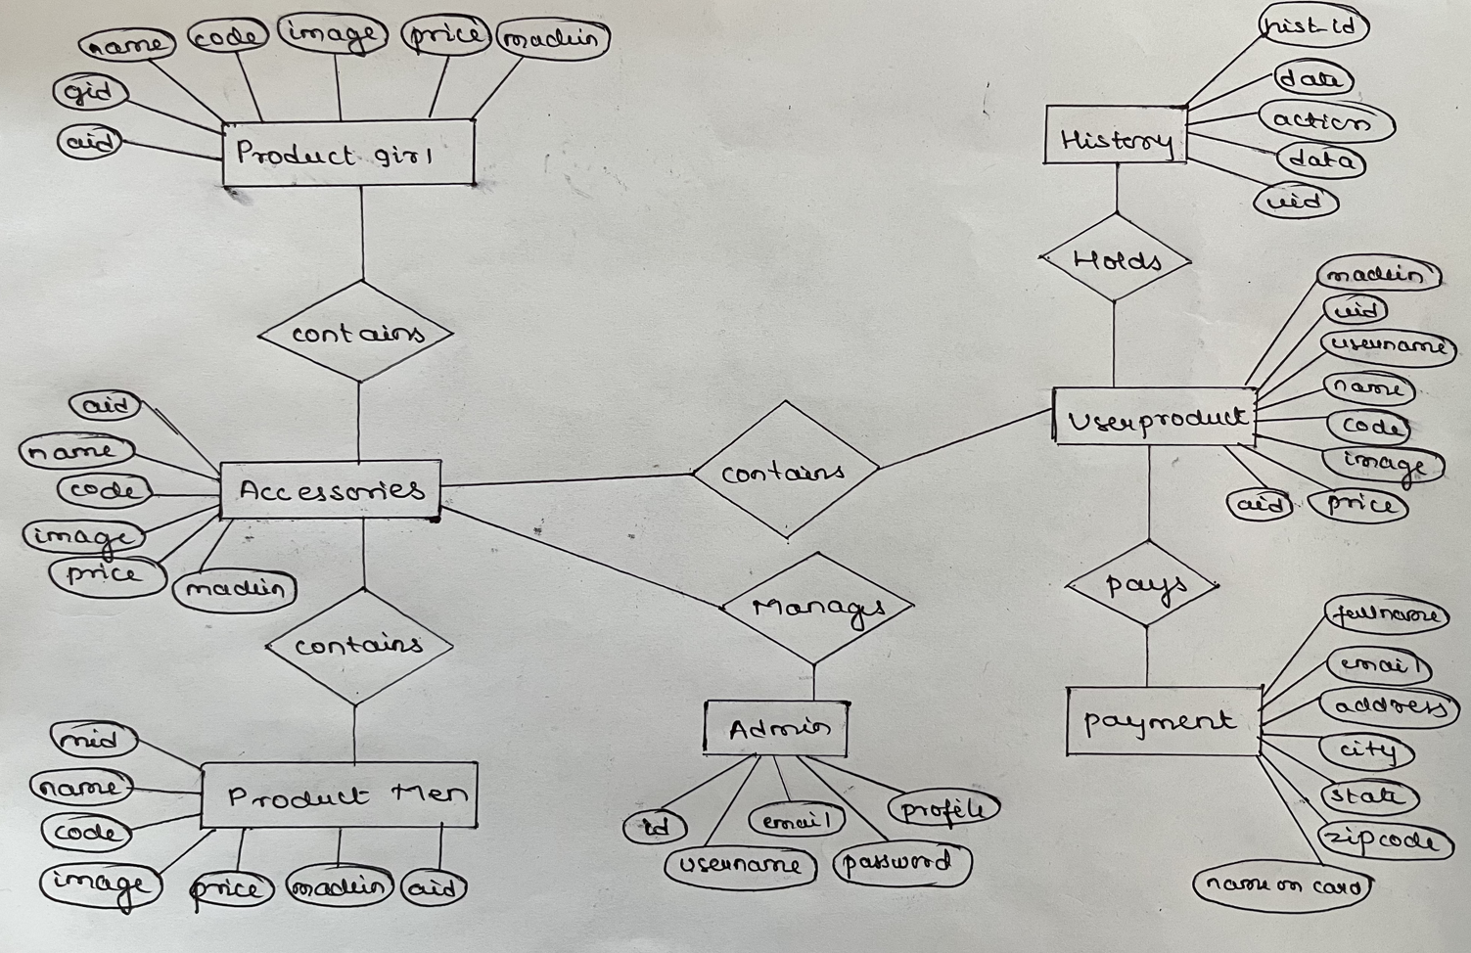

Fig.2.10:ER Diagram

**2.11 ANALYSIS**

**Mapping algorithm**

**Step1:** For each regular (strong) entity type E in the ER schema, create a relation R that includes all the simple attributes of E.

**Step 2:** For each weak entity type W in the ER schema with owner entity type E, create a relation R, and include all simple attributes (or simple components of composite attributes) of W as

attributes. In addition, include as foreign key attributes of R the primary key attribute(s) of the relation(s) that correspond to the owner entity type(s).

**step 3:** For each binary 1:1 relationship type R in the ER schema, identify the relations S and T that correspond to the entity types participating in R. Choose one of the relations, say S, and include the primary key of T as a foreign key in S. Include all the simple attributes of R as attributes of S.

**step 4:** For each regular binary 1: N relationship type R identify the relation (N) relation S. the primary key of T as a foreign key of S. Simple attributes of R map to attributes of S.

**step 5:** For each binary M: N relationship type R, create a relation S. Include the primary keys of participant relations as foreign keys in S. Their combination will be the primary key for S. Simple attributes of R become attributes of S.

**step 6**: For each multi-valued attribute A, create a new relation R. This relation will include an attribute corresponding to A, plus the primary key K of the parent relation (entity type or relationship type) as a foreign key in R. The primary key of R is the combination of A and K.

**step 7:** For each n-array relationship type R, where n>2, create a new relation S to represent R. Include the primary keys of the relations participating in R as foreign keys in S. Simple attributes of R map to attributes of S. The primary key of S is a combination of all the foreign keys that reference the participants that have cardinality constraint > 1. For a recursive relationship, we will need a new relation.

**2.12 SCHEMA DIAGRAM**

* A database schema is the skeleton structure that represents the logical view of the entire database. It defines how the data is organized and how the relations among them are associated.
* Database schema diagram or entity relationship diagram in relational database shows the logical view of the database schema.
* A database schema defines how data is organized within a relational database; this is inclusive of logical constraints such as table names, fields, data types and the relationships between these entities.
* Schemas commonly use visual representations to communicate the architecture of the database, becoming the foundation for an organisation’s data management discipline. This process of database schema design is also known as data modelling.
* These data models serve a variety of roles such as database users, database administrators and programmers.

For example, it can help database administrators manage normalization processes to avoid data duplication. Alternatively, it can enable analysts to navigate these data structures to conduct reporting or other valuable business analyses.

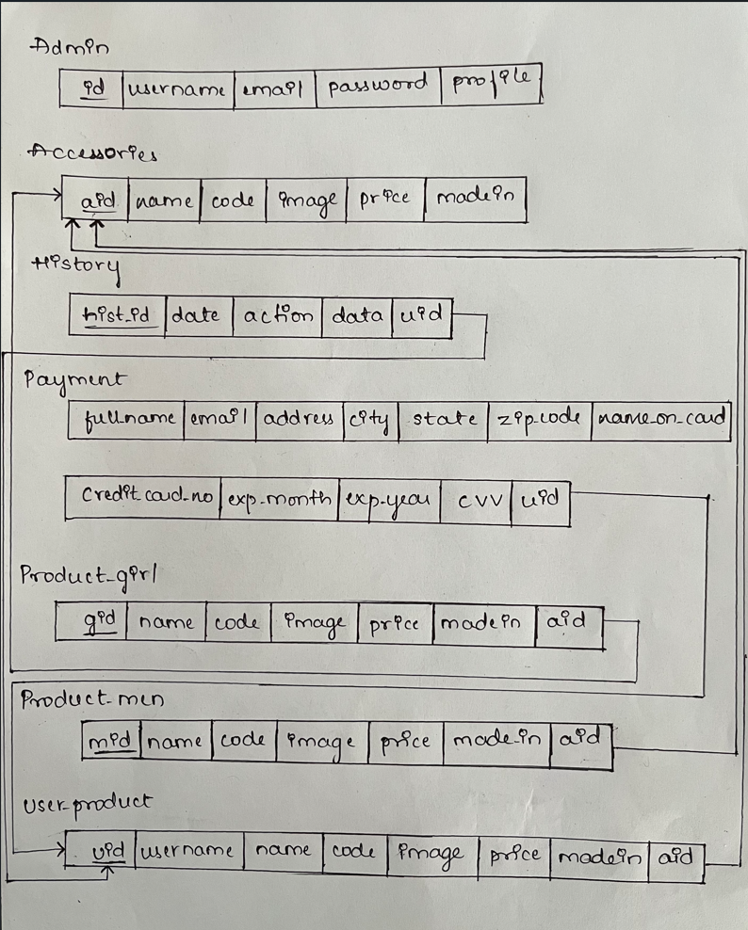fig.2.12:Schema Digram

**CHAPTER 03**

**IMPLEMENTATION**

**3.1 MODULES AVAILABLE IN APPLICATION**

* **Admin module**

This module is of admin, the person who is only has all permissions to modify the information of products in the shopping website.

Login

Manage Products

Manage users

* **Customer module**

This module is of customers who can visit the website and order the products.

Visit Website

Register

Login

**3.2 ACTORS DIAGRAM**

* User case diagram is also known as actor diagram.
* A use case diagram is used to represent the dynamic behaviour of a system. It encapsulates the system's functionality by incorporating use cases, actors, and their relationships.
* It models the tasks, services, and functions required by a system/subsystem of an application. It depicts the high-level functionality of a system and also tells how the user handles a system.
* The main purpose of a use case diagram is to portray the dynamic aspect of a system. It accumulates the system's requirement, which includes both internal as well as external influences. It invokes persons, use cases, and several things that invoke the actors and elements accountable for the implementation of use case diagrams.
* An actors diagram for an online kids shopping management system is a visual representation that shows the different roles and entities that interact with the system. It can help to understand the relationships and interactions between these actors and the system, and can also serve as a useful tool for communication and design.

1. **Customers:** The primary actors in the system, customers are parents or guardians who browse and purchase products for their children on the website. They can view products, add them to their cart, and proceed to checkout to make a purchase.
2. **Administrators:** Responsible for managing the website and its content, Administrators can add, edit or remove products, process orders, manage inventory and handle customer complaints.
3. **Payment gateway providers:** These actors handle online transactions and process payments from customers. They are responsible for ensuring the security of sensitive information such as credit card numbers and personal details.
4. **Shipping companies:** These actors handle the delivery of the products to customers. They receive shipping information from the system and update the status of orders as they are fulfilled.
5. **Product suppliers:** These actors provide the products that are sold on the website. They can update product information, pricing, and inventory levels.
6. **Customer service representatives:** These actors handle customer inquiries and issues that may arise. They can assist customers with order tracking, returns, and exchanges, and handle complaints and concerns.Top of FormBottom of Form

* An actor in a UML diagram represents a type of role where it interacts with the system and its objects.

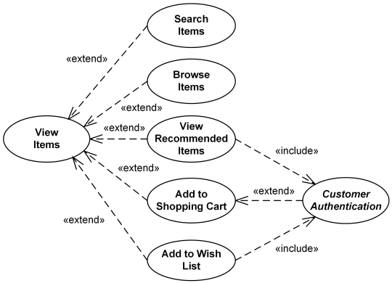

Fig.3.2(a): Actors Diagram

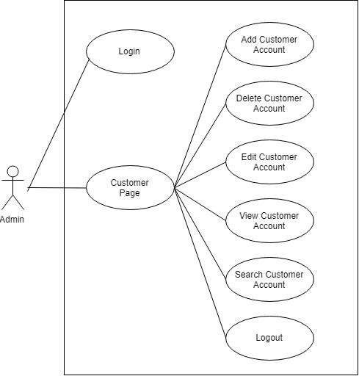

Fig.3.2(b): Admin’s Actor Diagram

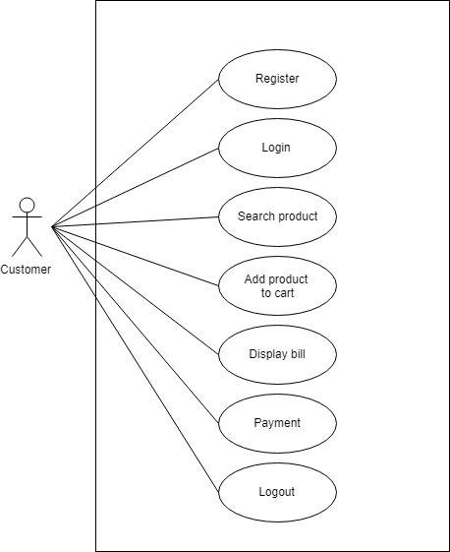

Fig 3.2(c): Customer’s Actor Diagram

**3.3 SYSTEM ARCHITECTURE**

A system architecture is the conceptual method that defines the structure, behaviour and more views of system. An architecture description is a formal description and representation of a system, organized in a way that supports reasoning about the structures and system architecture can comprise system components, the externally visible properties of those components, the relationships between them. It can provide a plan from which products can be produced and systems developed, that will work together to implement he overall system.

The architecture of an online shopping system for kids can vary depending on the type of system and the desired functionality. Generally, an online shopping system for kids would include the following components:

**1. Database:** A database is used to store customer information, product information, and transaction history.

**2. User Interface:** A user interface is used to allow customers to browse and purchase products, as well as view their shopping cart and order history.

**3. Payment Processing:** A payment processing system is used to securely process customer payments and track payment information.

**4. Security:** A security system is used to protect customer information and transactions. This could include encryption, authentication, and authorization.

**5. Delivery and Logistics:** A delivery and logistics system is used to manage the delivery of products and track their progress.

**6. Customer Support:** A customer support system is used to provide assistance to customers. This could include FAQs, customer service representatives, or live chat support.

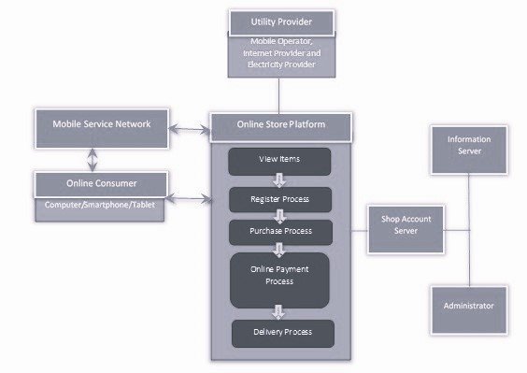

Fig.3.3(a): System Architecture

**3.4 BLOCK DIAGRAM**

* A block diagram is a drawing illustration of a system whose major parts or components are represented by blocks.
* These blocks are joined by lines to display the relationship between subsequent blocks.
* We use block diagrams to visualize the functional view of a system. It uses blocks connected with lines to represent components of a system.
* With a block diagram, we can easily illustrate the essential parts of a software design or engineering system and depict the data flow in a process flow chart.
* We can learn everything about a block diagram, including its uses and types.
* The block diagram of our whole application is as below:
  + A block diagram for a Kids Clothing Management System can help to explain how the system works. It consists of four main components: Input, Storage, Processing, and Output.
  + Input: This component is where data is entered into the system, such as the information needed to create a customer profile. This could include customer name, address, and size measurements.
  + Storage: This component is where the customer data is stored. It could be a computer database, or a physical filing cabinet.
  + Processing: This component is where the data is analyzed and used to generate reports or create customer orders.
  + Output: This component is where the output of the system is displayed, such as printed customer orders or inventory reports.

**3.5 SEQUENCE DIAGRAM**

There are 3 types of Interaction diagrams:

1. Sequence diagrams
2. Communication diagrams
3. Timing diagrams

* These diagrams are used to illustrate interactions between parts within a system. Among the three, sequence diagrams are preferred by both developers and readers alike for their simplicity.
* The sequence diagram represents the flow of messages in the system and is also termed as an event diagram. It helps in envisioning several dynamic scenarios.
* It portrays the communication between any two lifelines as a time-ordered sequence of events, such that these lifelines took part at the run time.
* A sequence diagram shows the sequence of messages passed between objects. Sequence diagrams can also show the control structures between objects.
* It simply reveals the structure of a system, showing the sequence of messages and interactions between actors and objects chronologically. Sequence diagrams show simple iteration and branching.
* A sequence diagram is structured in such a way that it represents a timeline which begins at the top and descends gradually to mark the sequence of interactions. Each object has a column and the messages exchanged between them are represented arrows.
* A sequence diagram for a Kids Clothing Management System shows how different components of the system interact and communicate with each other. The diagram shows the sequence of interactions between a user, a web server, and a database.
* The user begins by accessing the Kids Clothing Management System through their web browser. The web server then receives the request and checks the database for the requested information. If the information is found, the web server sends the data back to the user in the form of a web page.
* The user can then interact with the page, such as adding items to their shopping cart. Once the user has finished their purchase, the web server receives the order and stores the data in the database. The web server then sends a confirmation email to the user with the details of the purchase.
* Finally, the user is redirected to a thank you page with the details of their purchase.

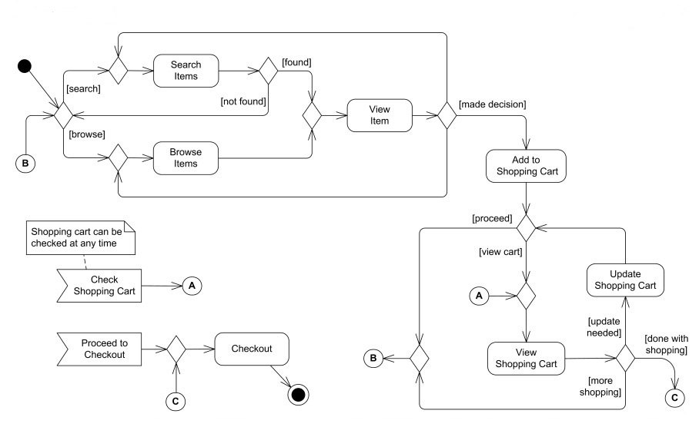

Fig.3.5(a): Sequence Diagram

* 1. **PLAN OF IMPLEMENTATION**

**1. Identify Target Audience:** Identify the target audience of the online kids management system. This includes the age range of the kids, the purpose of the system, and any other relevant information.

**2. Design System Architecture:** Design the system architecture of the online kids management system. This includes the software and hardware components, the data storage, and the networking.

**3. Develop User Interface:** Design the user interface of the online kids management system. This includes the navigation, the content, the visuals, and the overall usability.

**4. Develop Database:** Design the database for the online kids management system. This includes the tables, the data types, and the relationships between the tables.

**5. Test and Debug:** Test and debug the online kids management system. This includes testing the user interface and the database.

**6. Launch and Monitor:** Launch and monitor the online kids management system. This includes monitoring the system performance and usage.

**7. Maintenance and Upgrades:** Monitor and maintain the online kids management system. This includes upgrading the system when needed.

**CHAPTER 04**

**RESULTS AND DISCUSSION**

* 1. **VALIDATION**

Validation is a process whereby the data entered in the database is checked to make sure that it is sensible. For example, validation can be utilized to check that only Male or Female is entered in a sex field. It cannot check whether or not the data entered is correct. It can only check whether or not the data makes sense.

Validation is a way of trying to lessen the number of errors during the process of data input. Validation is carried out by the computer when you input data. It is a way of checking the input data against the set of validation rules.

The purpose of validation is to make sure that data is

a) logical

b) rational

c) complete and within acceptable limits.

**Database Validation Methods:**

Database Validation: Database validation is an important step in online kids shopping database management. It involves verifying the accuracy and consistency of the data stored in the database. This includes running checks on the integrity of the data, verifying accuracy of data types, and ensuring data consistency across tables.

* **Data type check -** The first is the field type check, which ensures that, for example, letters are not inserted in a field for numbers only. Another constituent of this check is input validation making sure that the input is error-free and does not have logical mistakes.
* **Code check -** This includes checks for required fields (ensuring that all the mandatory fields are filled) and attributes validation (verifying information against a list of attributes and seeing if the required attributes match).
* **Range check -** Also known as an [**attributes**](https://gepard.io/product-information-management/product-attributes-role) range check, this ensures that attributes stay within a certain range of values.
* **Format check -** This type of check ensures that inputted records precisely fit the predefined format. For example, an international phone number has a fixed format: + country code – (area code) – 3-digit prefix – 4-digit subscriber number. Any deviations, like the absence of a country code, are considered errors.
* **Consistency check -** This involves verifying data against a list of values that contain formatting rules and seeing if specified properties match. This check confirms that the input is logically consistent.
* **Uniqueness check -** This includes checking the uniqueness of specific attributes, such as brands, serial numbers, or [**MPN**](https://gepard.io/ecommerce-strategy/what-is-mpn-number) (Manufacturer Part Number), and making sure they are not entered into a database more than once.
  1. **LIMITATIONS**

However, the perfect you try to make a project, it always has certain limitations. TMS also suffers from certain limitations. These are:

### **Device:**

* + - A web-browser supporting HTML, CSS and JavaScript is required.
    - A minimum of a Pentium IV system with 512MB RAM with essential hardware like a
    - network card would be required.

### **Application:**

* + - The registration form in the website has been kept short asking only for critical
    - information, more fields like Age, DOB, etc. can be appended.
    - The feature to terminate the account has not been provided, it will have to be done manually (on site).
    - If teacher’s account details are leaked to a student, he can send false notices to students.

### **Data:**

* + - Although proper control has been given to the administrators to ensure incredulous
    - accounts are rejected upon inception, there is still a window of possibility of such events.
    - The security of the database could be strengthened further to protect against attacks like SQL injections.
  1. **TEST CASE WITH SNAPSHOTS**

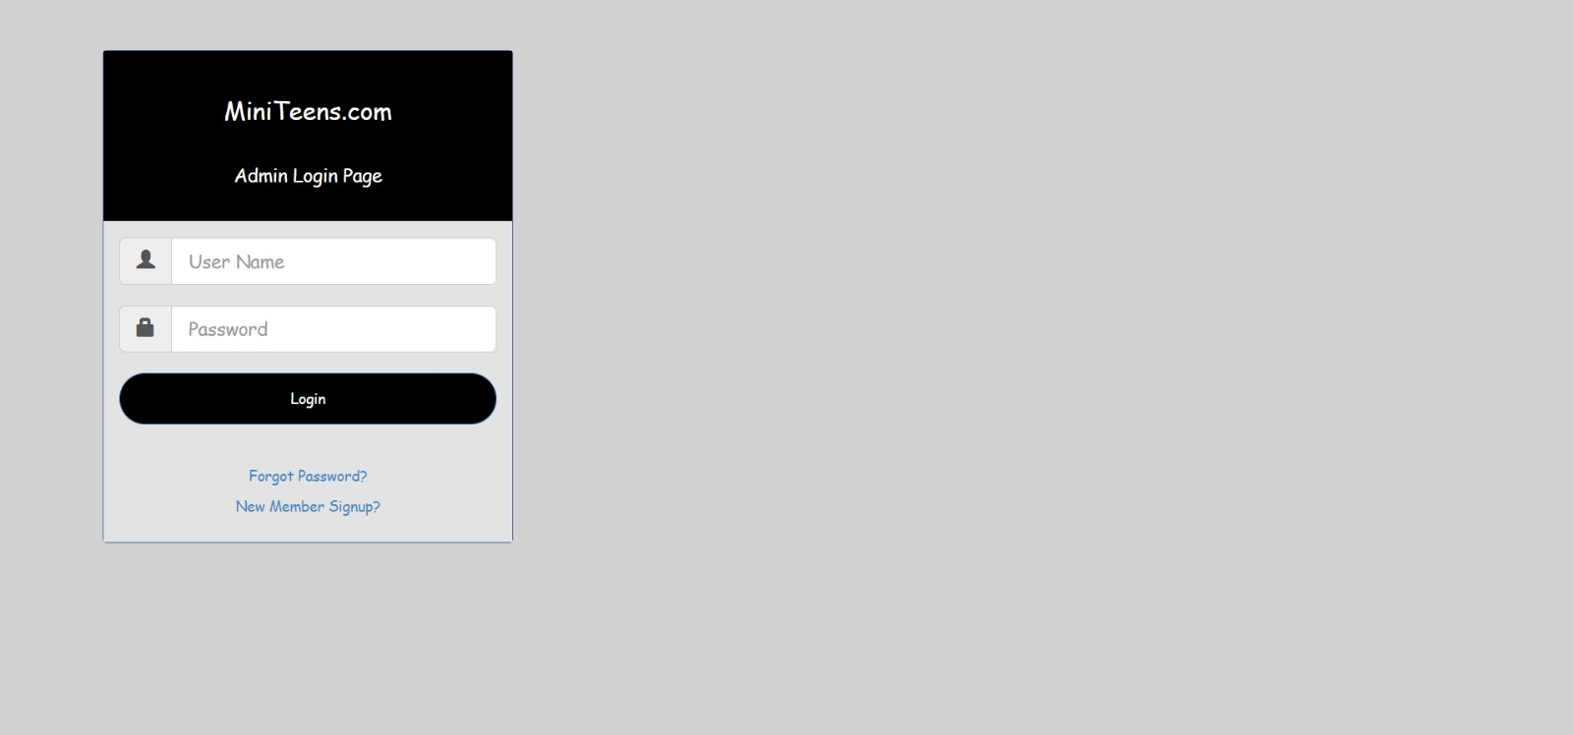

Fig:4.3 (a): Home page of our application.

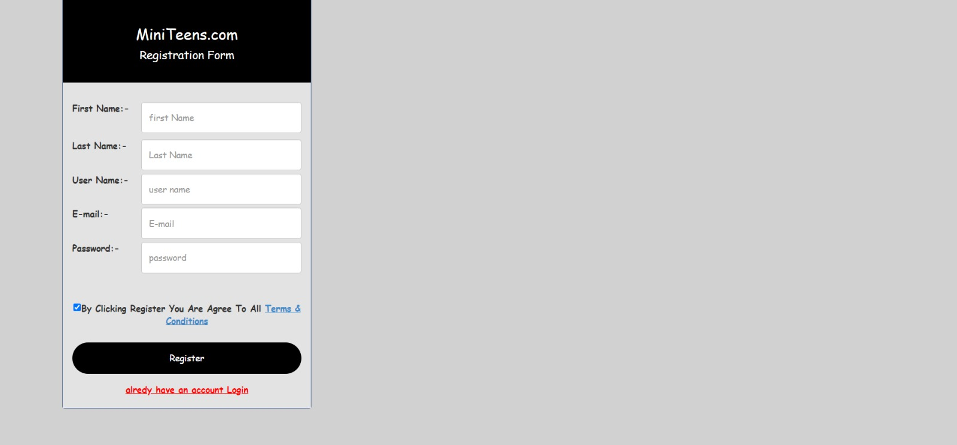

Fig.4.3(b): Customer Registration Page



Fig.4.3(c): Home Page

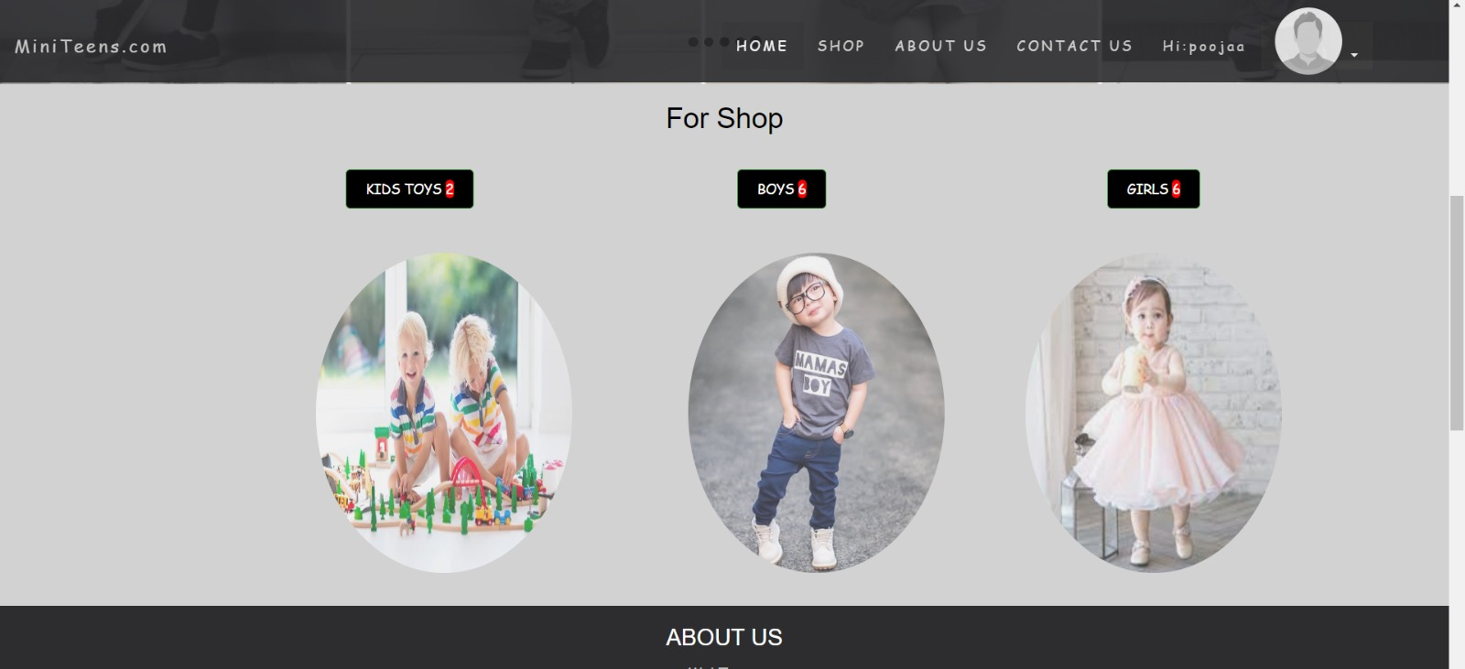

Fig.4.3 (d): Shopping Page

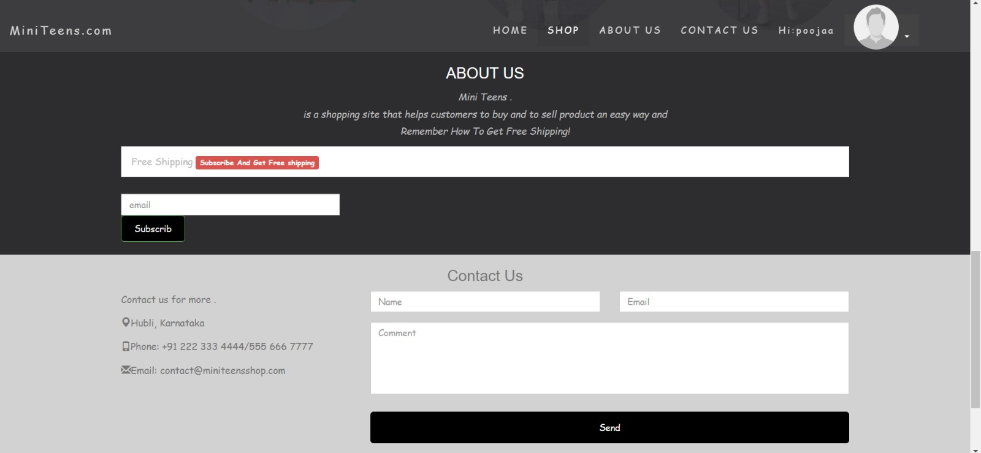

Fig.4.3 (e): About Website and Contact

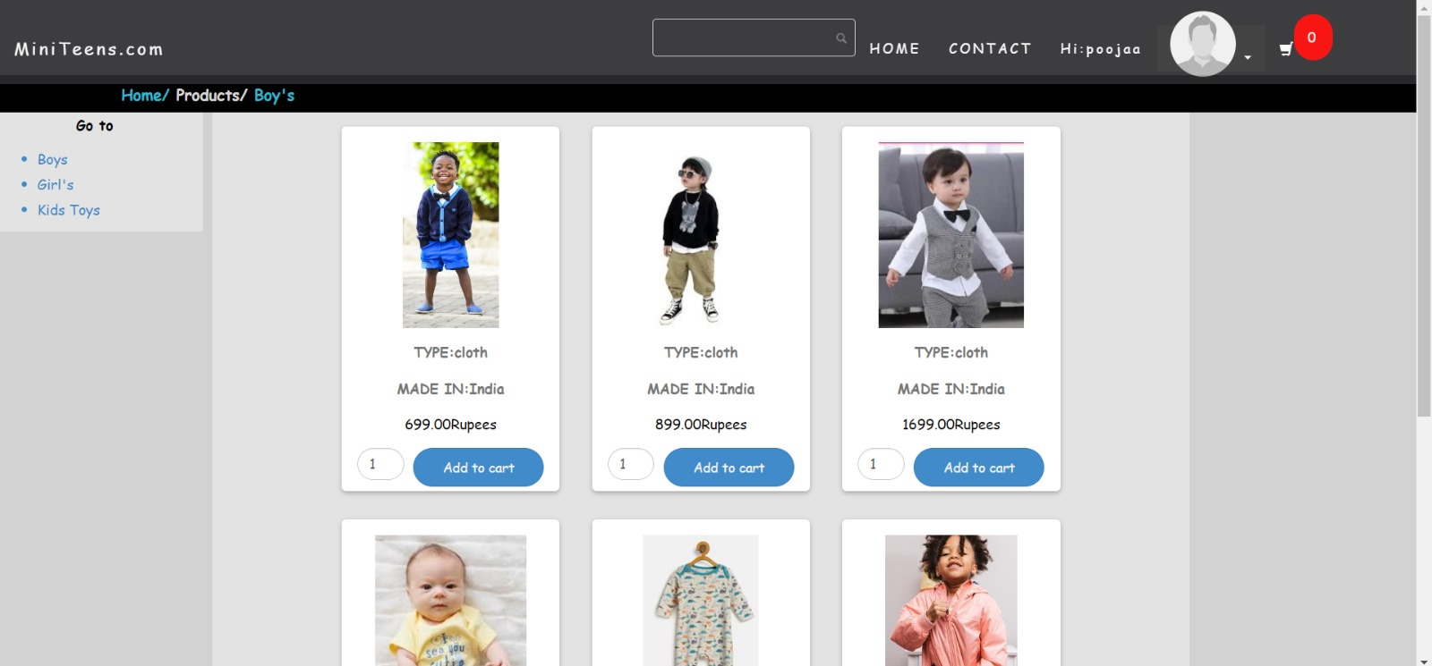

Fig.4.3 (f): Products

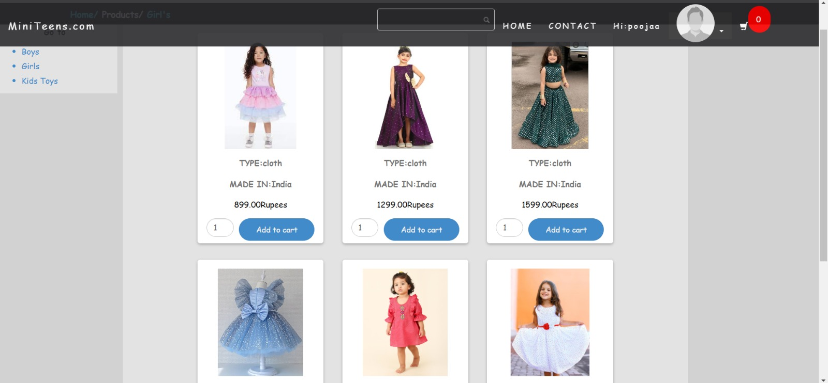

Fig.4.3 (g): Products

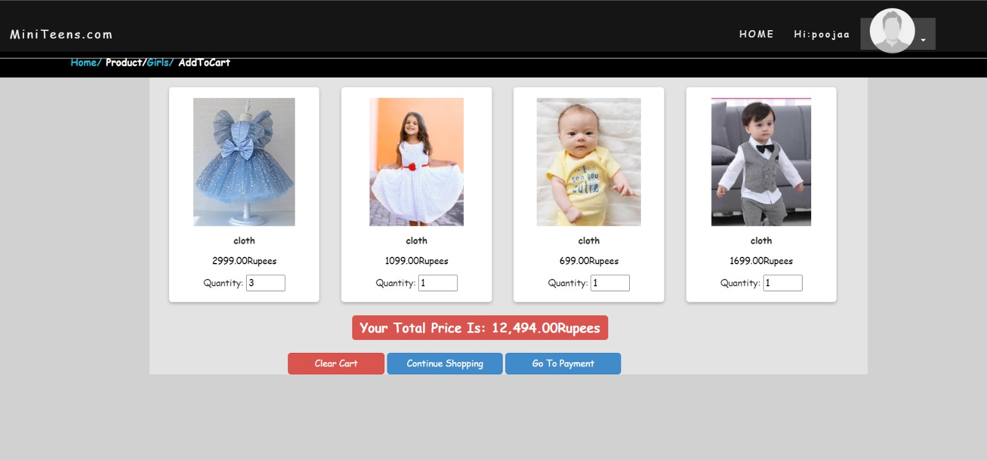

Fig.4.3 (h): Add to Cart Page

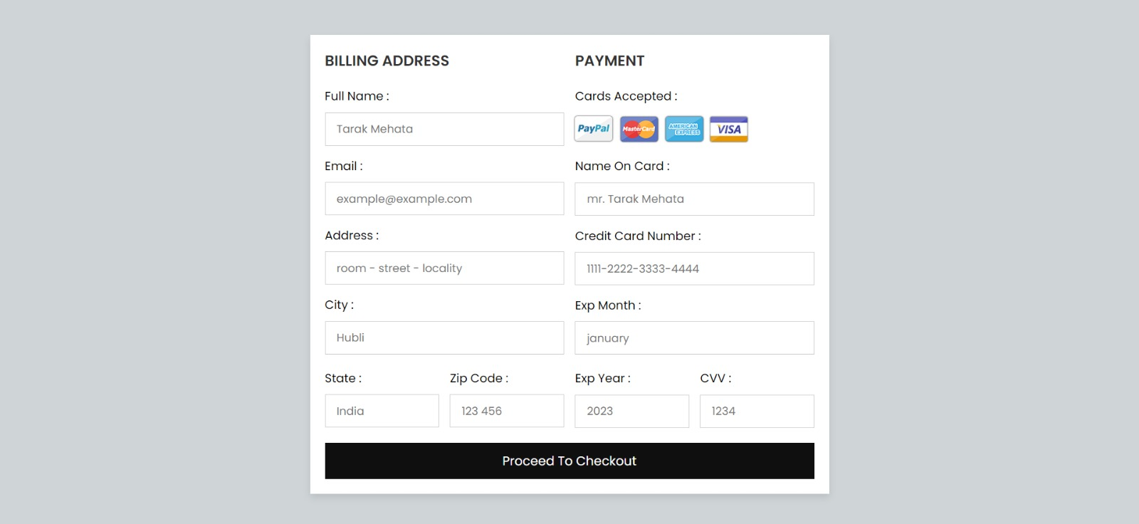

Fig.4.3 (i): Payment Page

**CHAPTER 05**

**FUTURE SCOPE AND CONCLUSION REFERENCES**

**5.1 FUTURE SCOPE AND CONCLUTION**

The most important part in doing this project was the lessons I learnt while the building of this system. It gave me a life time opportunity to understand about my strength and capabilities. It was really a challenge to use the knowledge gained during the degree in the practical world.

First, I created a time schedule to carry out the project and it showed me the importance of time management for every activity.

The implementation phase was the hardest part of the project but I enjoyed it very much. It allowed me to use programming languages such as PHP, Java script and CSS in practical world. My project needed lot of interviews with the staff and the Guests. As a result, I was able to build up my inter personal and communication skills.

Writing the dissertation was another challenge for me. I took a great effort to done it according to the standard level and it improved my writing skills.

Though the project was hard I am really happy and satisfy about the final outcome. This project made me understand the importance of the BIT final year project.

**5.2 OUTCOMES**

Prior to this project, a general study was conducted where an inspection was made of the previous system, which helped to uncover the misfits that the system was facing. After analyzation of these products a solution was then developed in order to meet up the needs of more advance system.

The advance system is designed in the way such that we can sort or differentiate the sold products data or available product data separately moreover the user’s data stored separately.

The motive of this Online Shopping Web Application is to allow the user to play with the search tool and create different combinatorial search criterion to perform exhaustive search.

Making the application AJAX enabled gets rid of these unnecessary delays letting the user to perform exhaustive search. The users of this application can easily feel the difference between the Ajax empowered user interfaces vs. traditional user interfaces. Provide Interactive interface through which a user can interact with different areas of application easily.

A search engine that provides an easy and convenient way to search for products specific to their needs. The search engine would list a set of products based on the search term and the user can further filter the list based on various parameters. Provide Drag and Drop feature thereby allowing the user to add products to or remove products from the shopping cart by dragging the products in to or out of the shopping cart.

The current system can be extended to allow the users to create accounts and save products in to wish list.

The users could subscribe for price alerts which would enable them to receive messages when price for products fall below a particular level.

The current system is confined only to the shopping cart process. It can be extended to have a easy to use check out process.

Users can have multiple shipping and billing information saved. During checkout they can use the drag and drop feature to select shipping and billing information.

**5.3 REFERENCES**

[1] David Gilbert , Pearson Education Low Price , 2nd Edition (2008) , New Delhi .

[2] Swapna Pradhan , Tata McGraw Hill Publishing , 2nd Edition (2007) , New Delhi .

[3] Suja Nair , Himalaya Publishing House , 3rd Edition (2008) , Mumbai .

[4] Michael Levy , Barton A Weitz and Ajay Pandit , Tata McGraw Hill Publishing , 6th Edition (2008) , New Delhi .

[5] Hoyer, W.D., McInnis, D.J. Pieters, Consumer Behavior, 6th Edition (2013), South-Western Cengage Learning.

[6] JavaScript Enlightenment,Cody Lindley-First Edition, based on JavaScript 1.5, ECMA-262, Edition.

[7] Mc GrawHill’s , Java : The complete reference 7thEdition, Herbert Schildit.

[8] Complete CSS Guide ,Maxine Sherrin and John Allsopp-O'Reilly Media; September 2012